The Lord’s Prayer

Our Father, who art in heaven, hallowed be thy name. Thy kingdom come, Thy will be done on earth as it is in heaven. Give us this day our daily bread and forgive us our trespasses, as we forgive those who trespass against us. And lead us not into temptation, but deliver us from evil. For thine is the kingdom, and the power, and the glory, forever. Amen.
*Singing Our Faith # 133 “Leaning on the Everlasting Arms”
*Blessing and Dismissal
*Postlude

Scatter to Serve God & Neighbor

Welcome to all! We gather to praise God for the innumerable blessings given to us and to grow deeper in the Spirit. Joyfully, let us lift our hearts to God.

DIRECTORY OF CHESTNUT HILL UNITED METHODIST CHURCH
Sue Haupert-Johnson |  | Richmond Area Resident Bishop
 | Denise Bates |  | Mountain View District Superintendent
 | Adam White |  | Minister
 | Erin Long |  | Associate Minister
 | Monica Campbell |  | Administrative Assistant
 | Heather Wilson |  | Director of Music Ministry
 | Judy Martin |  | Bookkeeper
 | Judy Robertson  Elizabeth Nichols |  | Lay Leader  Missionary in Henry County

C hestnut Hill
United Methodist Church

Making disciples of Jesus Christ
for the transformation of the world.
You are welcome at Chestnut Hill UMC.

4660 Fort Avenue ~ Lynchburg, Virginia 24502
Church: 434-239-8423
Minister’s Cell: 434-944-7723, Minister’s Email: awhite@ves.org
Associate Minister’s Cell: 1-502-489-0200
Associate Minister’s Email: healingsolutions12@gmail.com
Email: chestnuthillumc@comcast.net
On the Web at chestnuthillumc.net
Find us on Facebook: Chestnut Hill United Methodist Church

Chestnut Hill United Methodist Church
10:30 a.m. ~ April 14, 2024 ~ Third Sunday of Easter
Our ministry vision for the Virginia Annual Conference is “to be disciples of Jesus Christ who are lifelong learners, who influence others to serve.”

Welcome! Join us in worshiping God!

Prelude
Welcome and Ministry Announcements
Welcome in the name of Christ our Lord. Please register your attendance, printing your name, address, phone, and email, on the attendance pad provided on your pew. Thank you for silencing cell phones as we gather to worship God.
Invocation
*Greeting
The strife is o'er, the battle done;
the victory of life is won;
the song of triumph has begun.
Alleluia!
The powers of death have done their worst,
but Christ their legions has dispersed.
Let shouts of holy joy outburst.
Alleluia!
The three sad days are quickly sped;
he rises glorious from the dead.
All glory to our risen Head.
Alleluia!
*Singing Our Faith # 384 “Love Divine, All Loves Excelling”

Opening Prayer
Almighty and everlasting God, who in the Paschal mystery established the new covenant of reconciliation: Grant that all who have been reborn into the fellowship of Christ’s Body may show forth in their lives what they profess by their faith; through Jesus Christ our Lord, who lives and reigns with you and the Holy Spirit, one God, for ever and ever. Amen.

Anthem “Hymn of Promise”

Greeting Friends and Neighbors
Prayer for Illumination
Living God, by your Holy Spirit, open our eyes to see the new light of this day; open our lips to tell of the empty tomb; open our hearts to believe the good news; through Jesus Christ our Lord. Amen.
Scripture Lesson Luke 24:36b-48
The Word of God for the people of God.

Thanks be to God.
Singing Our Faith # 349 “Turn Your Eyes upon Jesus”
The Good News “See Food”

Bringing Forward God’s Tithes and Our Gifts
*Doxology # 95 Praise God from whom all blessings flow; praise him, all Creatures here below; praise him above, ye heavenly host; praise Father, Son, and Holy Ghost. Amen.
*Prayer of Thanksgiving
Sharing of Joys and Concerns

**Calendar **
Monday, 4/15 |  | Deadline for May newsletter articles.
Thursday, 4/18 | 6:00 p.m. | Homeschool Annual Member meeting
Friday, 4/19 |  | Church Office Closed
 | 10:00 a.m. | Homeschool
**Looking Ahead on the Calendar **
Sunday, 4/21 | 5:00 p.m. | Peaks View Charge Prayer Gathering  All are invited to uplift in prayer General Conference, April 23-May 3 in Charlotte, NC.
Thursday, 4/25 | 10:30 a.m. | Merry Marthas Circle  We will gather products to deliver to Miriam’s House.
Sunday, 4/28 | 10:00 a.m. | Choir

NOTE: We will have our roof, over the Fellowship Hall, replaced this week. Please use caution when entering the parking lot.

For the Grocery Cart: April
Pop-top cans of meats, soups, pasta dishes, and vegetables, body wash, and shampoo. Place donations in the grocery cart, located in the Commons.
Cards for Homebound Members
Please take a moment to sign the cards for our homebound members/friends that Erin has placed in the Commons.

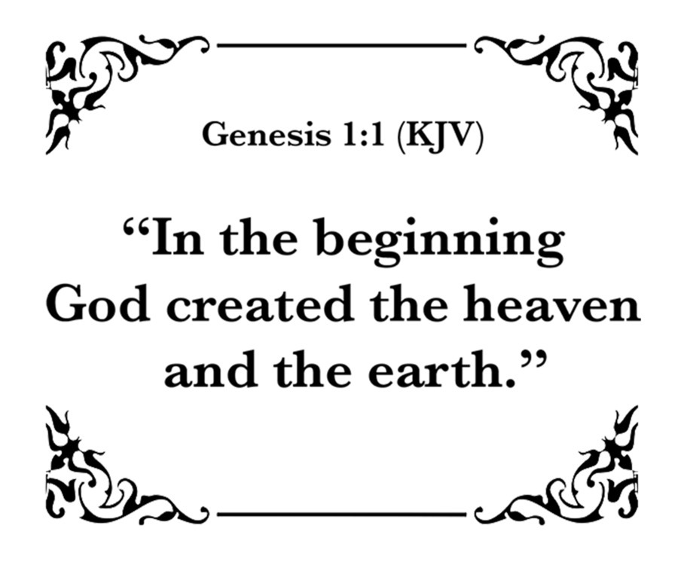

**Calendar **
Monday, 4/15 |  | Deadline for May newsletter articles.
Thursday, 4/18 | 6:00 p.m. | Homeschool Annual Member meeting
Friday, 4/19 |  | Church Office Closed
 | 10:00 a.m. | Homeschool
**Looking Ahead on the Calendar **
Sunday, 4/21 | 5:00 p.m. | Peaks View Charge Prayer Gathering  All are invited to uplift in prayer General Conference, April 23-May 3 in Charlotte, NC.
Thursday, 4/25 | 10:30 a.m. | Merry Marthas Circle  We will gather products to deliver to Miriam’s House.
Sunday, 4/28 | 10:00 a.m. | Choir

NOTE: We will have our roof, over the Fellowship Hall, replaced this week. Please use caution when entering the parking lot.

For the Grocery Cart: April
Pop-top cans of meats, soups, pasta dishes, and vegetables, body wash, and shampoo. Place donations in the grocery cart, located in the Commons.
Cards for Homebound Members
Please take a moment to sign the cards for our homebound members/friends that Erin has placed in the Commons.

